- Aşağıda verilen konularla ilgili paragraflar yazınız.
- DİKKAT!!!! Yazmadan önce anahtar kelimeleri bulmayı unutmayınız…

Konu:TEMBELLİK | …………………………………………………………….............................  ……………………………………………………………………………………………  ………………………………………………………………………………………………  ………………………………………………………………………………………………  ………………………………………………………………………………………………  ………………………………………………………………………………………………  …………………………………………………………………………………………………  …………………………………………………………………………………………………
Konu: ÇEVRE
KİRLİLİĞİ

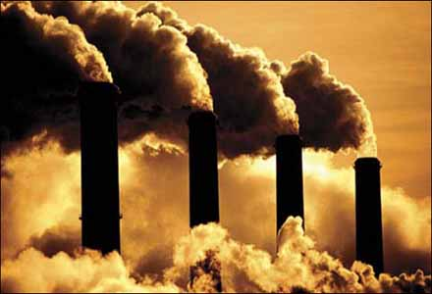

Konu: PLANLI
ÇALIŞMA

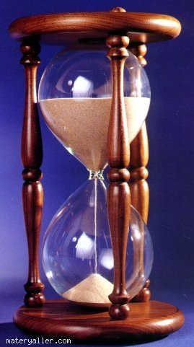

Konu : DOSTLUK |  | …………………………………………………………….............................  ……………………………………………………………………………………………  ………………………………………………………………………………………………  ………………………………………………………………………………………………  ………………………………………………………………………………………………  ………………………………………………………………………………………………  …………………………………………………………………………………………………  …………………………………………………………………………………………………
Konu: YAŞADIĞIMIZ  ŞEHİR |  | 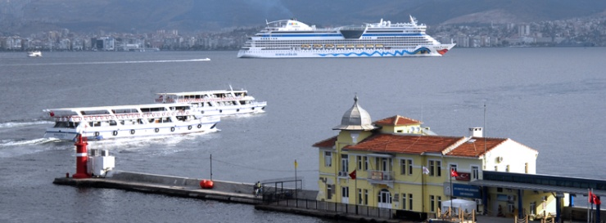
Konu: ÇOCUK

